Ideation Phase
Brainstorm & Idea Prioritization Template

Date | 5/7/2026
Team | Edralla Roja  Reddy Anusha
Project Name | Strategic product placement analysis: unveiling sales impact with tableau visualization

Brainstorm & Idea Prioritization Template:

PROJECT COMPONENT: BRAINSTORM & IDEA PRIORITIZATION

Project Name: Strategic Product Placement Analysis: Unveiling Sales Impact with Tableau Visualization

Objective: To identify and prioritize data-driven strategies that optimize product positioning to maximize retail revenue.

Conceptual Brainstorming

Before building the dashboard, we categorized potential factors that influence consumer behavior into four key areas:

- Spatial Mapping: How the physical layout (Aisle vs. Entrance) dictates foot traffic.
- Vertical Hierarchy: The impact of shelf height (Eye-level vs. Reach-level) on brand conversion.
- Product Affinity: The correlation between neighboring products (Crossmerchandising).
- Temporal Dynamics: How placement effectiveness changes based on peak shopping hours.

Idea Prioritization Framework
This framework serves as the roadmap for our analysis, categorizing ideas by their strategic value and implementation priority.

Category: Zone Profitability

- Description: Mapping revenue to a physical 2D store layout.
- Strategic Value: High. It identifies "Hot" spots (high sales) and "Cold" spots (dead zones). ● Priority: Critical (P1).

Category: Shelf-Level Lift

- Description: Calculating the percentage growth in sales when a product is moved to eye-level.
- Strategic Value: High. It optimizes the shelf stocking strategy for high-margin goods.
- Priority: Critical (P1).

Category: Market Basket Analysis

- Description: Analyzing if placement near complementary items increases the total order size.
- Strategic Value: Medium. It helps increase the Average Order Value (AOV). ● Priority: High (P2).

Category: Time-of-Day Impact

- Description: Determining if placement matters more during morning rushes versus evening rushes.
- Strategic Value: Low. It is harder to execute frequent physical changes to a store layout.
- Priority: Low (P3).

Implementation Logic
To execute these prioritized ideas, the project will follow this logical flow:

- For Zone Profitability: We will use Tableau Spatial Files or custom background images of the store floor plan to create a Heat Map. This allows stakeholders to visualize the "Value of Space" instantly.
- For Shelf-Level Lift: We will use Grouped Bar Charts to compare sales across four specific levels: Top Shelf, Eye-Level, Touch-Level, and Bottom Shelf.
- For Market Basket Analysis: We will utilize Highlight Tables to show the correlation between the placement of "Product A" and the sales lift of "Product B."

Strategic Justification
We have labeled Zone Profitability and Shelf-Level Lift as Critical. Because retail floor space is expensive, understanding the "Revenue per Square Foot" based on exact location provides the fastest Return on Investment (ROI) for store managers and

Step-1:

Team Gathering, Collaboration and Select the Problem Statement

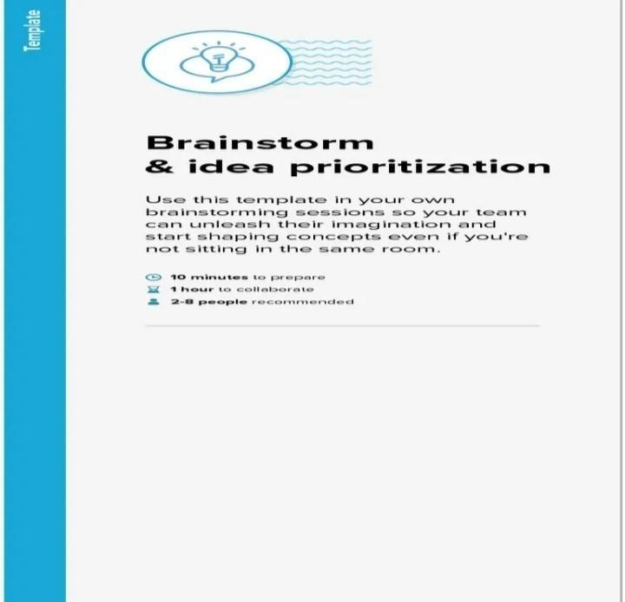
Step-2:

Brainstorm, Idea Listing and Grouping
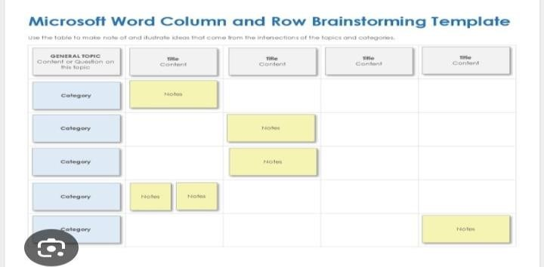

Step-3:

Idea Prioritization
